Coursera Storytelling

<https://www.coursera.org/learn/communicate-with-impact/home/welcome>

### **Week 5: Dealing with objections and overcoming resistance**

We all have something to sell, just like a sales team member. It doesn’t have to be selling products, but convincing people to agree with an idea.

With sales team, the tricky part is people think we are working for profit and we don’t CARE for them.

TO BE A TOP SALES PERSON: **HAVE GUIDELINES**

**Some rules in sales:**

1. Only sell something to someone who needs it
2. Only sell something you believe is of good quality
3. Only sell it at a price you think it’s worth

BOOK: **Getting to YES!** By Roger Fisher, William ury

There will be always conflicts. We always forget that **“TALKING HELPS”**

Talking will help building common ground and make agreements.

Why conflict happens in workplace?

1. **Desire for power and recognition:** Some people try to play above others instead of playing with others.
2. **Insecurity:** some people constantly seek for approval

We need to master the art of resolving differences, despite human weaknesses.

BOOK: **Why don’t people listen?** Hugh Mackay

The book says we only see the world from our own point of view and we are prisoners of our own thoughts.

Big question: **how to get others to see our point of view without making things worse?’**

**First Show Empathy:** by saying in the beginning : I can see where are you coming from. Or I understand why you are feeling this way. Or I can imagine how much work you have devoted tothis.

**Next**, offer an alternative view to create mutual understanding. E.g. what about looking at the problem this way? They key is to create an environment of sympathetic understanding. This way we can break the other party out of their cage.

**Next,** develop mutual trust: talk about positive expectations even if there is disagreements.

Important: If the conversation becomes tense, try to separate the person from the issue mentally, because the focus must be on solving the problem.

**Next,** try to find an area of a win-win situation. Try to show how both parties can benefit from solving the problem.

**Next,** both parties should try to find a mutual zone of acceptance, to minimize the conflict and differences.

People are willing to pay for expensive goods, if they see sufficient benefits of a specific product or idea.

In a sales meeting, if the buyer is not convinced show them benefits they never considered.

There is always objections. We need to predict them:

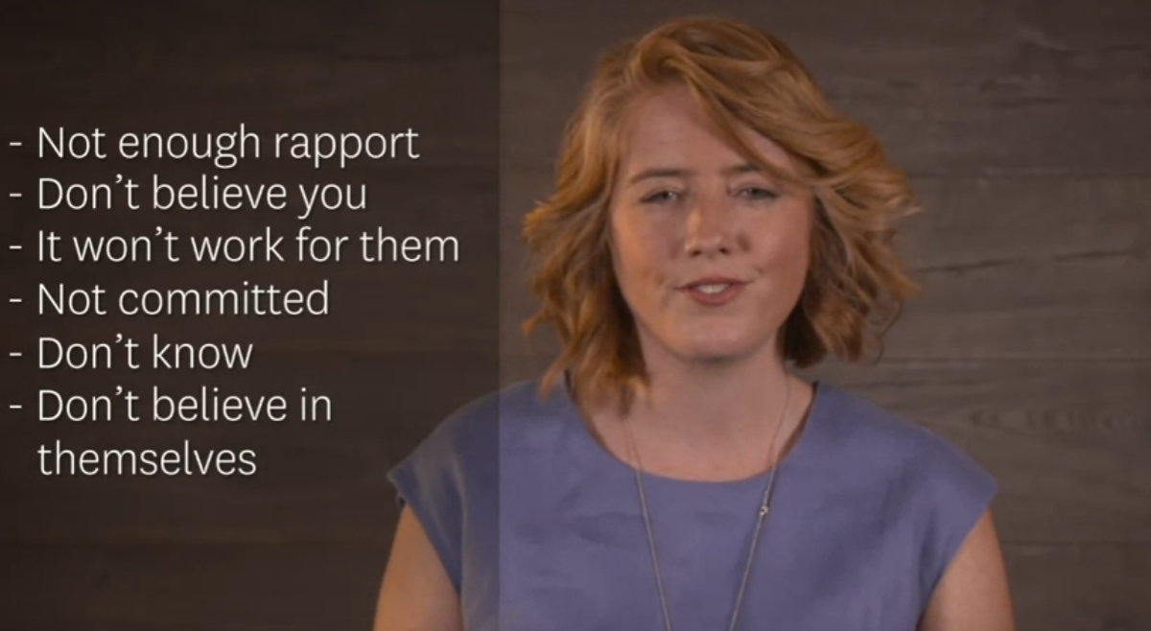

To deal with it you need to have a proper answer for all objections:

Before a sales pitch, do a review of other options to reassure yourself there are many other options, there is no need to get nervous.

Milton Model:

Reduces resistance by giving a suggestion that is so vague. This will occupy the conscious mind, and you can speak directly to the unconscious mind(the decision making center) you can use it only if we have rapport with the person. Only use them in a positive way.

6 top techniques to deal with objections:

* A person in a blue dress

  Description automatically generated with medium confidenceMind read:
* Lost performative:

* Cause and effect:

* Presupposition: For example, you are learning many things.

You can do this even better.

You are changing all the time.

You're seeing things differently now.

* Universals: something no one can argue with:

For example, nobody's perfect.

Everyone loves a good deal.

No one likes losing money.

Everyone needs experts when they have problems.

It's always better to ask someone who knows.

* Tag question:

You like getting things done well, don't you?

You don't like our competitors, do you?

You can get me this by 3:00 PM, can't you?

Links:

<https://www.youtube.com/watch?v=P_6vDLq64gE>

<https://www.youtube.com/watch?v=QIRk382yJm4>

<https://blog.hubspot.com/sales/sales-statistics>